PRACTICAL 10

Problem statement: use modus tollens for building inference engine

Solution:

Introduction: **Modus Tollens** is a fundamental rule of inference in propositional logic. It states:

* If P  ⟹  QP \implies QP⟹Q (If PPP, then QQQ), and
* ¬Q\neg Q¬Q (not QQQ),
* Then ¬P\neg P¬P (not PPP).

This logical rule is powerful for deriving conclusions in reasoning systems, especially for negation-based inference.

Code:

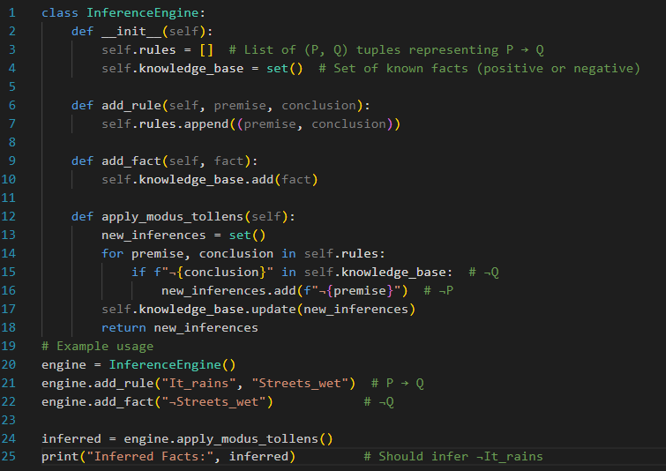

Output:

